Citations:

<https://mlexplained.com/2018/01/18/paper-dissected-deep-image-prior-explained/>

Prior distribution:

* <https://brainstore.tistory.com/48>
* https://ko.wikipedia.org/wiki/%EC%82%AC%EC%A0%84_%ED%99%95%EB%A5%A0

Content:

“Deep learning is driven by big data and big compute”. This is the popular sentiment among many of those involved in the field of AI. A primary example that is given to support this claim is ImageNet, a massive dataset of natural images that has contributed greatly to the advancement of deep learning in computer vision. Many people believe that deep learning only works in the context of massive datasets or models pretrained on such datasets.

“Deep Image Prior”... showing that the structure of the convolutional neural network (CNN) contains “knowledge” of natural images.

It showed that some tasks – such as denoising and super-resolution – can actually be successfully conducted on a single image, without any additional training data.

Priors are used in generative models to ensure that we gain “natural” outputs. In the context of image generation, priors restrict the output image to resemble natural images instead of noise.

Randomly initialized convolutional neural networks (CNNs) that are used to generate images have an implicit “prior”: they resist generating noisy images and have a bias towards natural images

A prior is short for “prior distribution”, which is intuitively a distribution that represents our basic beliefs in the absence of information.

In the case of images, a prior distribution over images basically represents what we think natural images should look like. Consider the following two images:

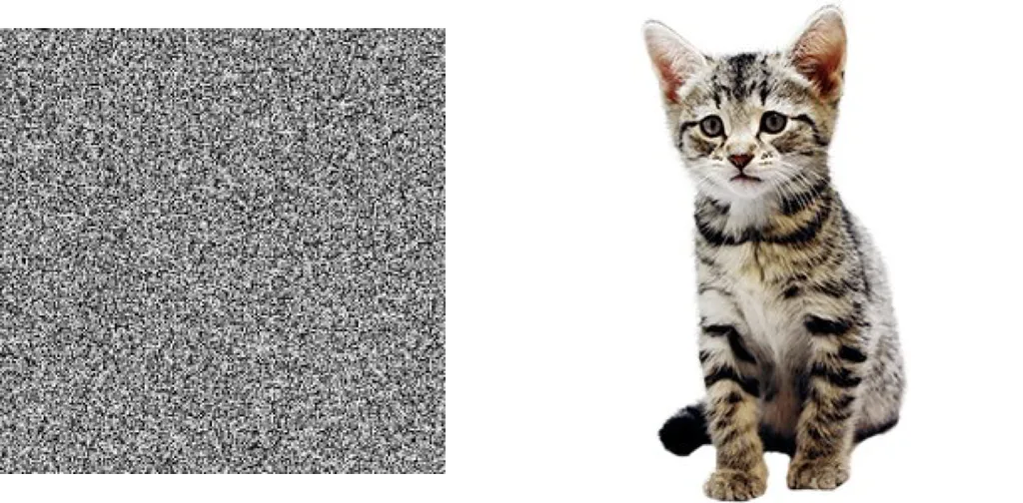

The fact that we recognize one as a natural image and the other as noise indicates that humans have some implicit prior over what natural images should look like.

Regularizers can often be interpreted as incorporations of prior distributions.

For instance, l2 regularization represents a belief that weights should be zero on average, and larger weights should be exponentially rarer compared to smaller weights. This is equivalent to putting a Gaussian prior over the weights.

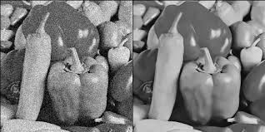

A straightforward approach to this problem would be to train a neural network that takes noisy images as input and outputs the denoised image. This is called a learning-based approach. The problem with this is that this approach requires massive amounts of noisy and denoised image pairs

Suppose now that we do not want to use any additional data. How do we perform denoising in this scenario?

One approach is to think of this problem as an optimization problem. We aim to create an image x that is both close to the noisy image but is “noise-free”, clear” and “natural“.

We can measure the “closeness” of images with the l2 distance between the pixel values || x - xo||^2 .

Suppose for a moment that there was a function that could measure the “naturalness” or “clearness” of an image \textrm{naturalness}(x) .

For the sake of aligning the notation with the original paper, we will use the term R(x) = -\textrm{naturalness}(x) for the remainder of this post. R(x) measures the “unnaturalness” or “unclearness” of an image. In this case, our optimization objective would be

min || x - xo||^2 + R(x) .

The attentive reader might have already noticed, but the term R(x) represents our prior over natural images and is, therefore, a “regularization term”. Without the regularization term R(x) , the optimizer will “overfit” on the noisy image – i.e. it will just return the noisy image. Therefore, how we define this prior/regularization term is crucial in obtaining high-quality results.

Unfortunately, we do not have an exact prior over natural images. Traditionally, we have used hand-crafted features to represent the prior, but these always involve some level of arbitrariness. The essence of this paper is that CNNs can be used as priors over images; in other words, CNNs in some way “know” what natural images should and should not look like. The remainder of this post will explain how the paper has verified this statement and its explanation behind it.

2. How do CNNs define a prior?

…

The authors found that while adding depth was beneficial, adding skip-connections was actively harmful for producing good results.

This shows that the network architecture is an important factor in producing good results, particularly in generative models – perhaps far more than we had previously thought.

Korean:

안녕하세요 저희는 15조의 17학번 김혜원, 19학번 권은혁입니다.

저희가 “Deep Image Prior”이라는 주제를 선택한 이유는 많은 데이터를 학습하지 않고도 단 한장의 사진에 있는 정보만을 이용해 denoising, imprinting, super resolution과 같은 작업들을 수행 할 수 있다는 사실을 더 깊게 알아보고 싶었기 때문입니다.

딥러닝은 많은 데이터를 학습해서 원하는 결과를 보여주는 것으로 많이 알려져 있습니다. 14million장의 이미지를 학습하여 2만개의 카테고리로 분류할 수 있는 ImageNet이 이것의 대표적인 예라고 할 수 있습니다. 이것은 컴퓨터 비전 분야에 딥러닝의 발전에 크게 기여하였습니다. 그리고 이러한 영향으로 사람들은 딥러닝은 엄청나게 많은 양의 데이터를 꼭 학습할 필요로 하는 것으로 생각합니다.

하지만 저희가 찾은 ‘Deep Image Prior’은 CNN(convolutional neural network)자체가 자연스러운 이미지의 특성을 잡아낼 수 있다는 것을 발견했습니다. 따라서 많은 데이터의 학습 없이도 CNN자체만으로 denoising과 super resolution과 같은 작업을 성공적으로 수행 할 수 있다는 말입니다.

‘Deep Image Prior’에서 ‘Prior’이라는 단어는 무엇을 뜻하는 말일까요?

이것은 ‘prior distribution’을 줄인 말로 한국어로는 ‘사전확률'이라고 합니다. “현재 가지고 있는 정보를 기초로 하여 정한 초기 확률”, “관측자가 관측을 하기 전에 가지고 있는 확률 분포를 의미”한다고 합니다. 조금 더 쉽게 설명하자면 어떤 이미지에 대해서 ‘자연스러움'이 무엇인지에 대한 우리의 생각을 대표하는 것이라고 생각하면 됩니다.



우리가 위의 두 그림중 하나는 고양이이고 다른 하나는 그저 노이즈인 것을 알 수 있는 이유가 인간에게는 잘 정리되어 있는 내재적인 prior가 있기 때문입니다

기존의 model-based approach에서는 이 자연스러움을 측정할 수 있는 알고리즘을 직접 제작했었습니다.

The fact that we recognize one as a natural image and the other as noise indicates that humans have some implicit prior over what natural images should look like.

Regularizers can often be interpreted as incorporations of prior distributions.

For instance, l2 regularization represents a belief that weights should be zero on average, and larger weights should be exponentially rarer compared to smaller weights. This is equivalent to putting a Gaussian prior over the weights.

A straightforward approach to this problem would be to train a neural network that takes noisy images as input and outputs the denoised image. This is called a learning-based approach. The problem with this is that this approach requires massive amounts of noisy and denoised image pairs

Randomly initialized convolutional neural networks (CNNs) that are used to generate images have an implicit “prior”: they resist generating noisy images and have a bias towards natural images

A prior is short for “prior distribution”, which is intuitively a distribution that represents our basic beliefs in the absence of information.

In the case of images, a prior distribution over images basically represents what we think natural images should look like. Consider the following two images:

CNN도